**ZINGO – THE SONGS**

|  |
| --- |
| 1. Suzan & Freek – Blauwe dag |
| 1. Queen – Don’t stop me now |
| 1. Guus Meeuwis – Het is een nacht |
| 1. Shawn Mendes & Camila Cabello - Senorita |
| 1. Davina Michelle – Duurt te lang |
| 1. Lady Gaga - Shallow |
| 1. Nick & Simon – Rosanne |
| 1. Panic! at the disco – High hopes |
| 1. Billie Eilish – Bad guy |
| 1. Lil Nas X ft. Billy Ray Cirus – Old town road |
| 1. Claudia de Breij – Mag ik dan bij jou? |
| 1. The beatles – Let it be |
| 1. Blof – Harder dan ik hebben kan |
| 1. Beyoncé – If I were a boy |
| 1. Pink – Walk me home |
| 1. Train – Hey, soul sister |
| 1. Eminem – Love the way you lie |
| 1. Krezip – Lost without you |
| 1. Nick & Simon – Pak maar m’n hand |
| 1. Lucas Graham – 7 years |
| 1. Marco Borsato – Hoe het danst |
| 1. The white stripes – Seven nation army |
| 1. Lady Antebellum – Need you now |
| 1. Nirvana – Smells like teen spirit |
| 1. USA for Africa – We are the World |
| 1. The weeknd – I can’t feel my face |
| 1. Alicia Keys - Underdog |
| 1. Avicii – Wake me up |
| 1. Adele – Rolling in the deep |
| 1. Ed Sheeran – Shape of you |
| 1. Mark Ronson – Uptown funk |
| 1. Sheppard – Die young |
| 1. Lewis Capaldi – Before you go |
| 1. Kensington – Do I ever |
| 1. Billy Joel – The piano man |
| 1. Walk the moon – Shut up and dance |
| 1. Diggy Dex – Treur niet |
| 1. 5 seconds of summer - Teeth |
| 1. Kenny B - Parijs |
| 1. James Bay – Hold back the river |
| 1. Blof - Zoutelande |
| 1. George Ezra - Shotgun |
| 1. Glennis Grace - Afscheid |
| 1. Swedish house maffia – Don’t you worry child |
| 1. Muse - Starlight |
| 1. Dua Lipa – Don’t start now |
| 1. Danny Vera – Hold on to let go |
| 1. Post Malone – Circles |
| 1. Pharell Williams – Happy |
| 1. Imagine dragons – On top of the world |
| 1. Meghan Trainor – All about that bass |
| 1. Shakira – Waka waka |
| 1. Bruno Mars – 24K magic |
| 1. Robin Thicke – Blurred lines |
| 1. Katy Perry – Dark Horse |
| 1. John Legend – All of me |
| 1. Hozier – Take me to church |
| 1. Gotye – Somebody that I used to know |
| 1. Jason Mraz – I won’t give up |
| 1. Passeger – Let her go |
| 1. Charlie Puth – One call away |
| 1. The Script – Superheroes |
| 1. Ceelo Green – Fuck you |
| 1. André Hazes jr. – Leef |
| 1. Anouk – Lost |
| 1. De jeugd van tegenwoordig – Sterrenstof |
| 1. Caro Emerald – A night like this |
| 1. The common linnets – Calm after the storm |
| 1. Dotan – Home |
| 1. Mr. Probz – Nothing really matters |
| 1. Rag’n’Bone man – Human |
| 1. DNCE – Cake by the ocean |
| 1. David Guetta – Titanium |
| 1. Years & years - King |
| 1. Coldplay – Sky full of stars |

**ZINGO**



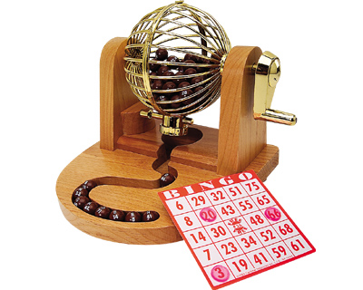

**Hét zangspel voor iedereen!**